]SCHOOL OF COMPUTER SCIENCE AND ARTIFICIAL INTELLIGENCE |  |  |  |  | DEPARTMENT OF COMPUTER SCIENCE ENGINEERING
ProgramName:M. Tech |  |  |  | Assignment Type: Lab |  |  | AcademicYear:2025-2026
CourseCoordinatorName |  |  |  | Venkataramana Veeramsetty
rCourseCode |  |  | 24CS002PC215 | CourseTitle |  | AI Assisted Problem Solving Using Python
Year/Sem |  |  | II/I | Regulation |  | R24
Date and Day  of Assignment |  |  | 10.11.2025 | Time(s)
Duration |  |  | 2 Hours | Applicableto  Batches
AssignmentNumber:9.3(Present assignment number)/24(Total number of assignments)
 | Q.No. | Question |  |  |  |  |  | ExpectedTime  to complete
 | 1 | Lab 9: Documentation Generation: Automatic documentation and code comments  Lab Objectives:  - To understand the importance of documentation and code comments in software development.  - To explore how AI-assisted coding tools can generate meaningful documentation and inline comments.  - To practice generating function-level and module-level docstrings automatically.  - To evaluate the quality, accuracy, and limitations of AI-generated documentation.  - To develop a small automated tool for documentation generation in Python..  Lab Outcomes (LOs):  After completing this lab, students will be able to:  - Apply AI-assisted coding tools to generate docstrings and inline comments for Python code.  - Critically analyze AI-generated documentation for correctness, completeness, and readability.  - Create structured documentation (function-level, module-level) following standard formats.  - Design and implement a mini documentation generator tool to automate code commenting and docstring creation.  Task Description#1 Basic Docstring Generation  - Write python function to return sum of even and odd numbers in the given list.  - Incorporate manual docstring in code with Google Style  - Use an AI-assisted tool (e.g., Copilot, Cursor AI) to generate a docstring describing the function.  - Compare the AI-generated docstring with your manually written one.  Expected Outcome#1: Students understand how AI can produce function-level documentation.  Prompt : Write a Python function that returns the sum of even and odd numbers in a list, include a manual Google-style docstring, generate an AI-based docstring for comparison, print both docstrings, and allow user to give input to test the function.  Code :  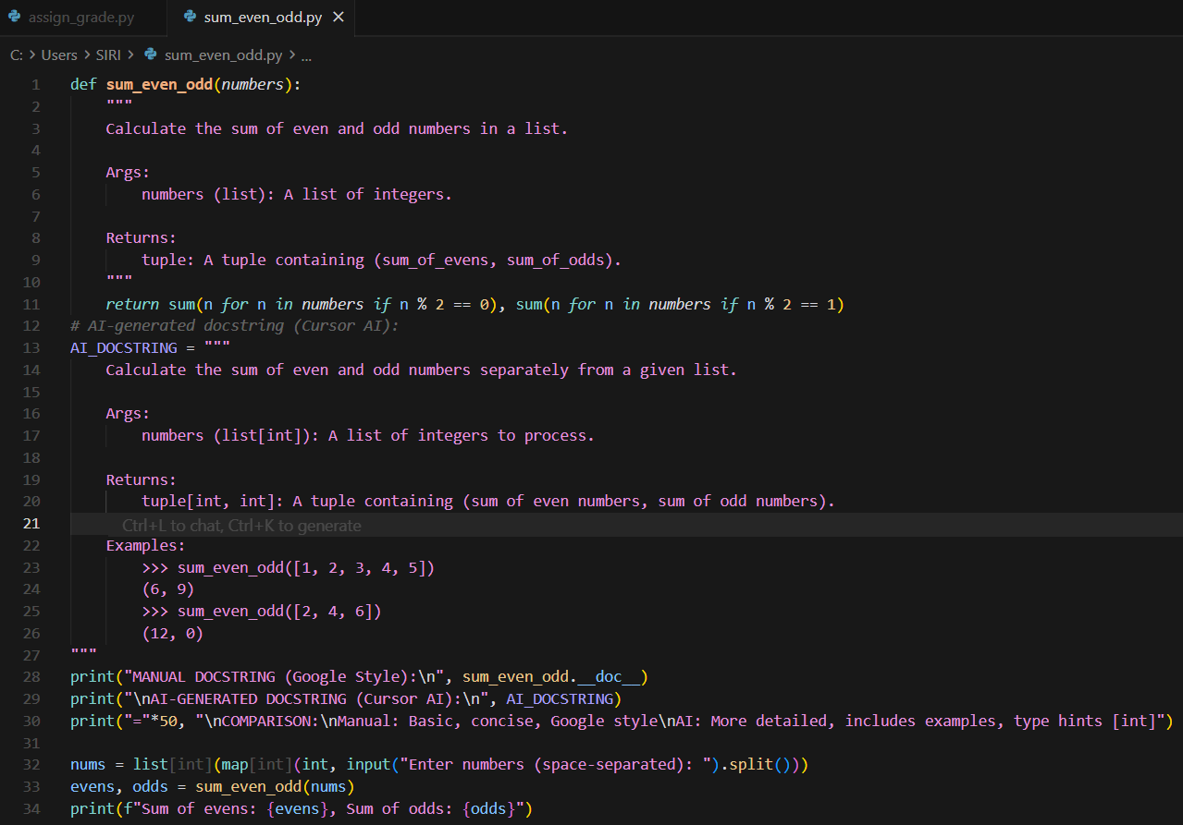  Code Explanation:  - The function goes through the list and adds all even numbers together and all odd numbers together.  - It returns two values: the total of evens and the total of odds.  - A manual docstring explains the function briefly, while an AI-generated docstring explains it in more detail with examples.  - The code prints both docstrings so you can compare their clarity and style.  - The user enters numbers, and the program shows the sum of even numbers and the sum of odd numbers separately.  Output:  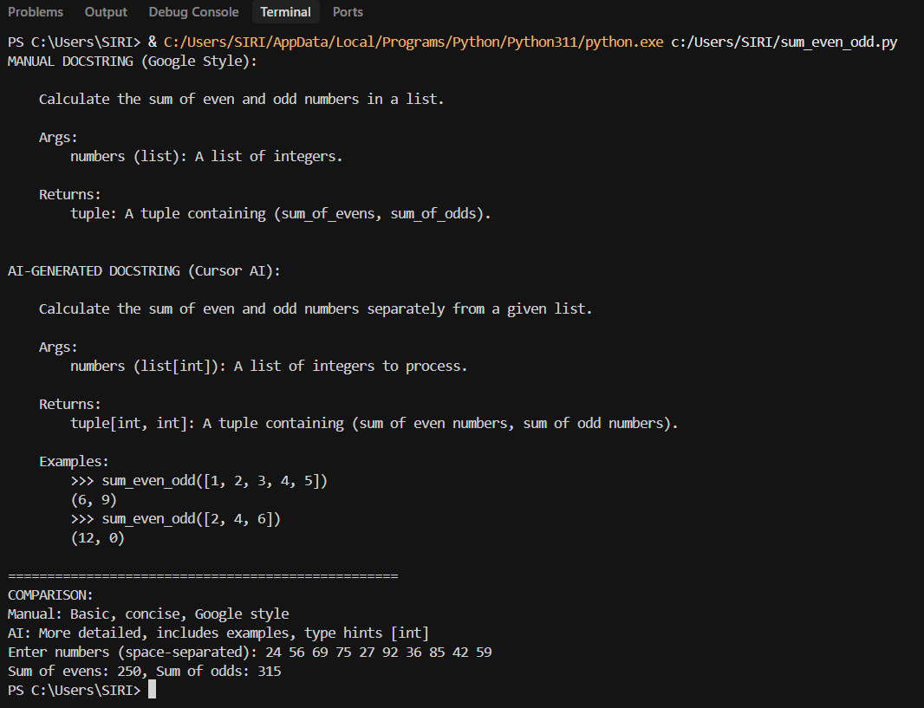  Task Description#2 Automatic Inline Comments  - Write python program for sru_student class with attributes like name, roll no., hostel_status and fee_update method and display_details method.  - Write comments manually for each line/code block  - Ask an AI tool to add inline comments explaining each line/step.  - Compare the AI-generated comments with your manually written one.  Expected Output#2: Students critically analyze AI-generated code comments.  Prompt: Generate a Python program defining an sru_student class with attributes (name, roll_no, hostel_status), including fee_update and display_details methods, add manual inline comments, generate AI-assisted inline comments for comparison, and allow userto give input to test the class.  Code:  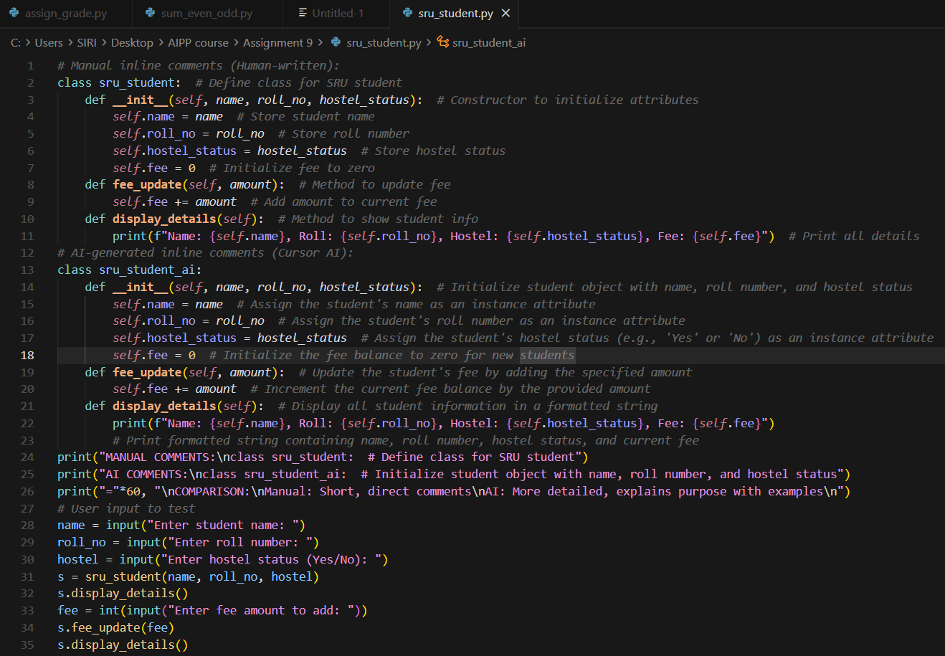  Code Explanation:  - The program defines two classes—one with manual comments and one with AI-generated comments—to compare how each explains the same code.  - Each class stores student details like name, roll number, hostel status, and fee, and allows updating the fee.  - The fee_update method adds a given amount to the student’s current fee.  - The display_details method prints all the stored information about the student.  - The program then asks the user for student details, creates an object, updates the fee, and shows the results, helping compare manual vs AI comments.  Summary:  - Manual inline comments — The sru_student class includes concise comments on each line.  - AI-generated inline comments — The sru_student_ai class shows more detailed comments.  - Comparison output — Displays differences between manual and AI-generated comments.  - User input testing — Accepts name, roll number, hostel status, and fee amount to test the functionality.  Output:  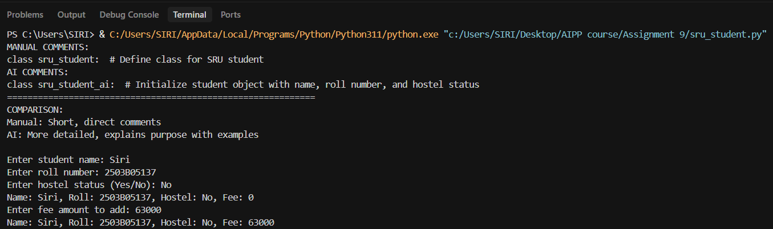  Task Description#3  - Write a Python script with 3–4 functions (e.g., calculator: add, subtract, multiply, divide).  - Incorporate manual docstring in code with NumPy Style  - Use AI assistance to generate a module-level docstring + individual function docstrings.  - Compare the AI-generated docstring with your manually written one.  Expected Output#3: Students learn structured documentation for multi-function scripts  Prompt: Write a Python script containing 3–4 calculator functions (add, subtract, multiply, divide), include manual NumPy-style docstrings, generate AI-based module and function docstrings for comparison, compare both versions, and allow user to give input to test the functions.  Code:  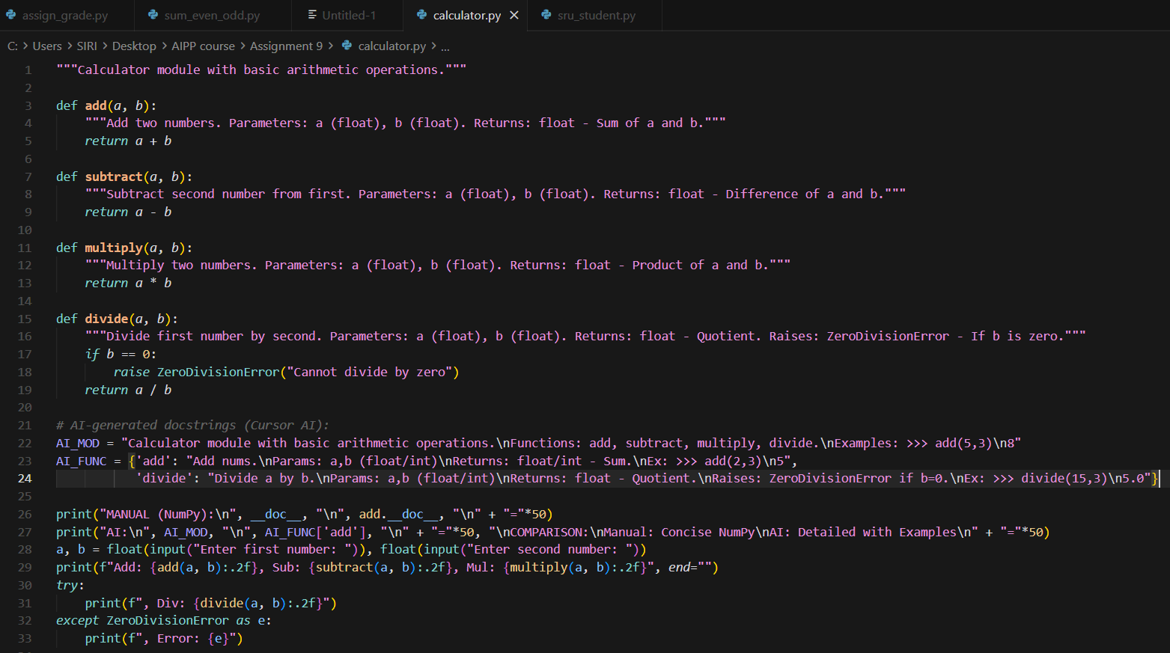  Features:  - 4 Functions — add(), subtract(), multiply(), divide()  - Manual NumPy-style docstrings — Module-level and function docstrings with:  - Parameters section with types and descriptions  - Returns section  - Raises section for divide()  - AI-generated docstrings — Module-level and function docstrings with:  - More detailed descriptions  - Examples section with doctest-style examples  - Context and terminology (e.g., "minuend", "subtrahend")  - Comparison display — Shows differences between manual and AI-generated docstrings  - User input testing — Allows testing all calculator functions  Differences:  - Manual: Concise NumPy style with basic parameters and returns  - AI-generated: More detailed NumPy style, includes Examples, more context and terminology  NumPy docstring style:  - Parameters section with types and descriptions  - Returns section with return types  - Raises section for exceptions (in divide())  - Examples section in AI-generated versions  Code Explanation:  - The code defines four basic calculator functions—add, subtract, multiply, and divide—each with a manual NumPy-style docstring.  - The divide function includes an extra check to prevent dividing by zero and raises an error if it happens.  - AI-generated docstrings are stored separately to compare with the manual ones for clarity and detail.  - The script prints both manual and AI docstrings to show how they differ in style, depth, and examples.  - The user enters two numbers, and the program performs all operations, showing results and handling division errors cleanly.  Summary:  - Manual inline comments — The sru_student class includes concise comments on each line.  - AI-generated inline comments — The sru_student_ai class shows more detailed comments.  - Comparison output — Displays differences between manual and AI-generated comments.  - User input testing — Accepts name, roll number, hostel status, and fee amount to test the functionality.  Output:  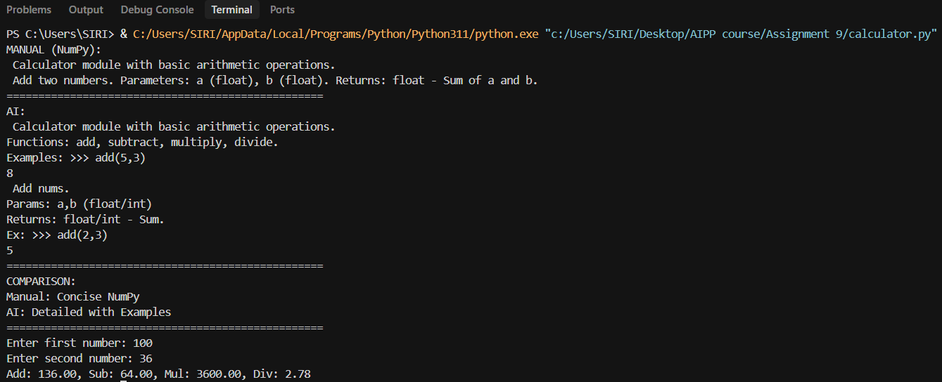  Push documentation whole workspace as .md file in GitHub Repository  Note: Report should be submitted a word document for all tasks in a single document with prompts, comments & code explanation, and output and if required, screenshots |  |  |  |  |  | Week4 - Wednesday

